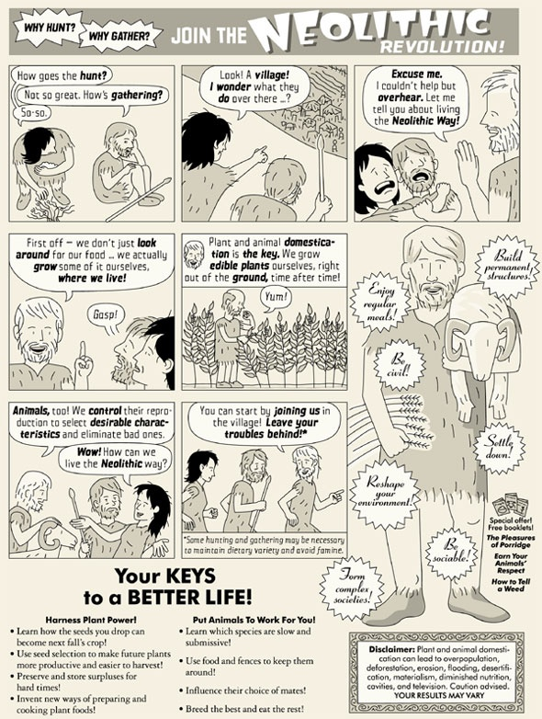
What causes society to change from a Paleolithic to a Neolithic one? What happened as a result of these changes? Explain using ideas from the document and facts learned from previous lessons.
_______________________________________________________________________________________________________________________________________________________________________________________________________________________________________________________________________________________________________________________________________________________________________________________________________________________________________________________________________________________________________________________________________________________________________________________________________________________________________________________________________________________________________________________________________________________________________________________________________________

