Sample Outline for Magazine Cover: You must make your cover about the place and or person that you wrote about. All pictures, title, and storyline must reflect this.

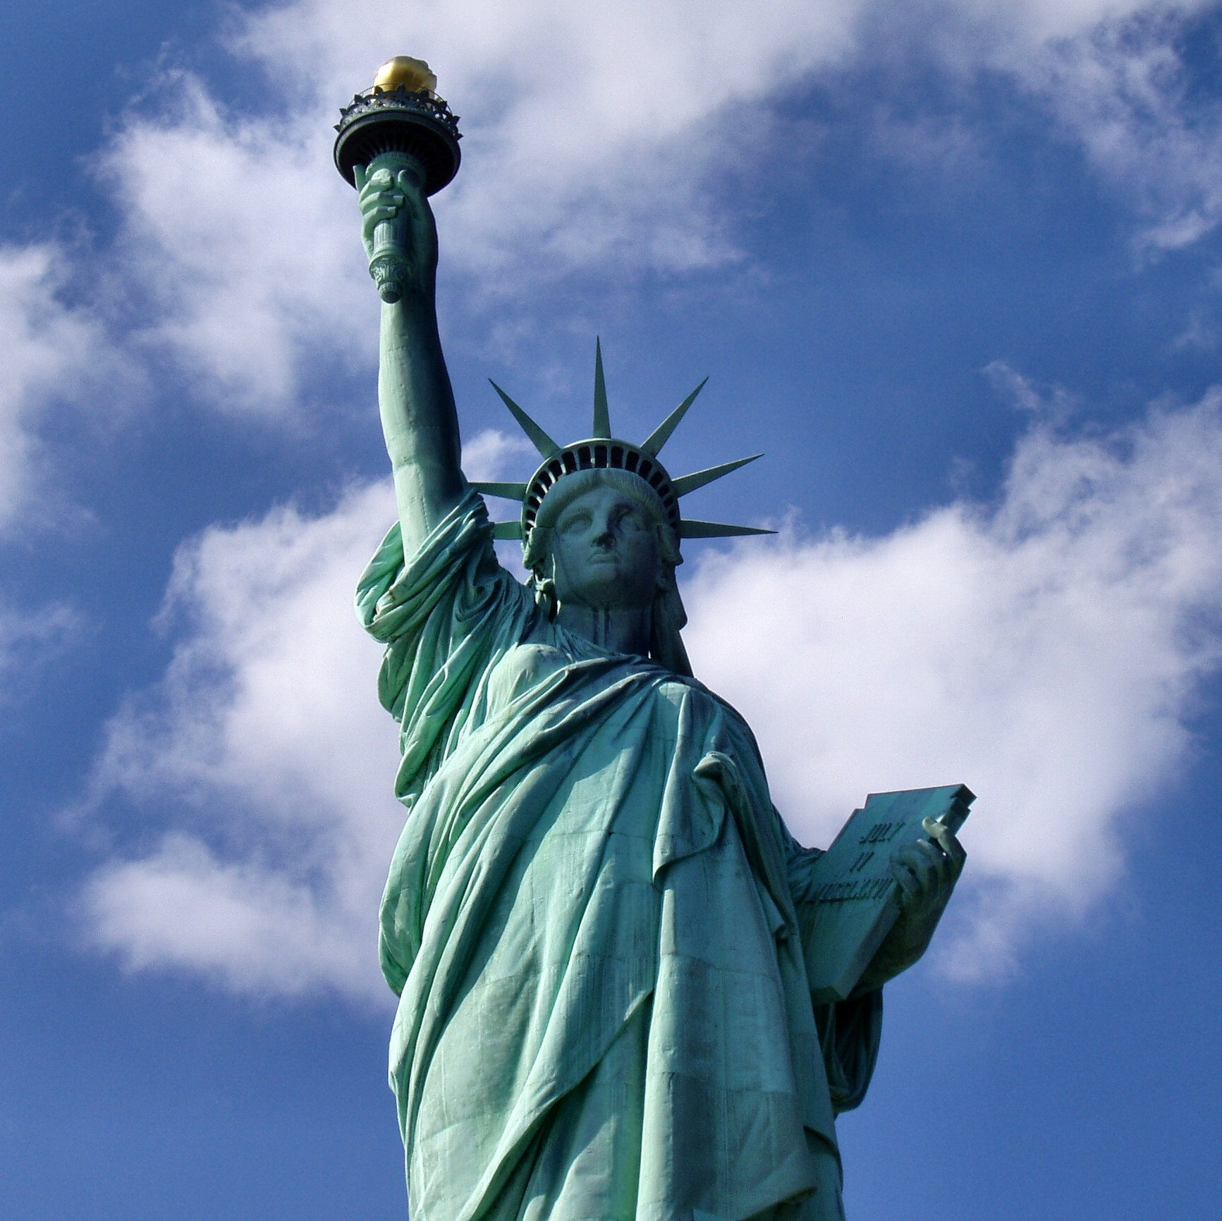

|  |  |
| --- | --- |
| |  | | --- | | **Title**: This must be in a larger font that all other headings. You may choose where on the page you want to place your title. (Look on line for example of magazine cover) |   Vol 3: October 2018  **What makes New York, New York?(Picture and story line)**  C:\Users\admin\AppData\Local\Microsoft\Windows\Temporary Internet Files\Content.IE5\4M30Z46G\thali1[1].jpg  From My Table to Yours (Story line)  C:\Users\admin\AppData\Local\Microsoft\Windows\Temporary Internet Files\Content.IE5\Q07TIN86\15586-illustration-of-a-dancing-cartoon-blue-man-pv[1].pngC:\Users\admin\AppData\Local\Microsoft\Windows\Temporary Internet Files\Content.IE5\Q07TIN86\train-clipart[1].jpg  **The Joys and Woes of Riding the Subway (Storyline)**        Image result for bar code with price  Give me Liberty Give Me Freedom  An immigrant story |