September 2010 Archives

Blog #1 - Different Types of Child Abuse
By JUDITH HITE on September 15, 2010 5:07 PM| 0 Comments | 0 TrackBacks

Child abuse...what are your first thoughts or visions as you think of this subject. Do you visualize a child being abused by their family or strangers? Do you think of a child being burned or beaten? Do you see a child sitting alone and neglected in a corner with barely enough food to eat. These are the many facets of child abuse. I am sure you can think of many more in your mind. We have seen it on television, hear PSAs on the radio and see posters around doctor's offices regarding this topic. However, we are going to get to know child abuse at a deeper level than what is just seen in the public's eye. This blog is meant to get you thinking about the many facets of harm done to children, to find a way to help our youngest victims who have no voices, and maybe even to shed a few tears. Our purpose is to get you to do whatever is possible to help stop the abuse regardless of a disability or no disability at all.
You will see a blue ribbon at the beginning of each of our blogs which is an international sign for Child Abuse Prevention. The color blue was represents the bruises and battered bodies of many children that who are abused every day. It is a continuous reminder that all of us have a responsibility to keep all of our children safe.
More articles on child abuse indicate that "adults abused during childhood are more than twice as likely to have at least one lifetime psychiatric diagnosis, almost three times likely to have an affective disorder, almost three times as likely to have an antisocial problem." Personally I had never looked at the figures like that and realized the true impact that child abuse has on the life of a child.
There are many incidences of child abuse that harms our children every day. The statistics are staggering. The following are two different charts depicting the ages of abuse and the types of abuse that happens every day.

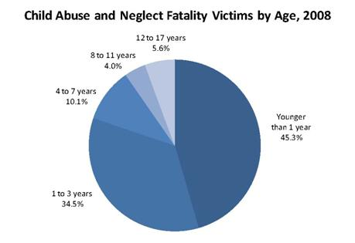

Source: http://webapp.cdc.gov/sasweb/ncipc/leadcaus10.html. Statistics regarding child homicide can be obtained from the U.S. Department of Justice athttp://bjs.ojp.usdoj.gov/content/homicide/children.cfm.

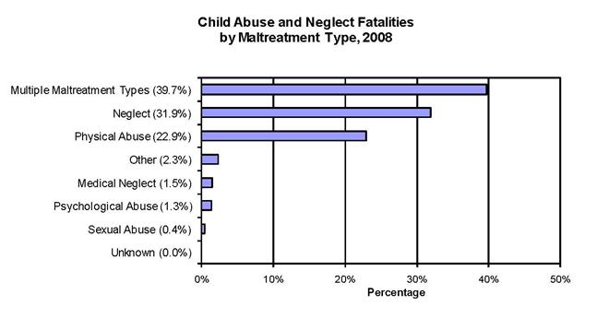

Source: http://webapp.cdc.gov/sasweb/ncipc/leadcaus10.html. Statistics regarding child homicide can be obtained from the U.S. Department of Justice athttp://bjs.ojp.usdoj.gov/content/homicide/children.cfm.
_____________________________
Physical Abuse
Children with disabilities are 3.4 times more likely to be physically maltreated than those children without disabilities, and 9 out of every 1,000 children with disabilities are physically maltreated.
For further information, please visit http://www.cehd.umn.edu/
Children with disabilities are at a greater risk of experiencing abuse. Signs of abuse among children with disabilities are often ignored or mistaken to be a part of the disability.
Physical abuse among the disabled can be defined as "any act which results in a non-accidental physical injury"
Source: http://www.prandicenter.org/Resources/ChildAbusedisabilities.pdf
Different types of physical abuse include bruises, burns, abrasions, lacerations, swelling, belt buckle mars, hand prints, bite marks, or pinches.
Some ways to tell if it is non-accidental physical abuse include if the injury is unusual for that specific age group, if there is a history of previous or recurrent injuries, and if there are unexplained injuries or conflicting explanations or reasons for injury. Please see the link below for further information.
Because of the abuse, there can be educational difficulties with which the child may have difficulty overcoming such as the inability to focus at school due to problems in the home. The socio-emotional outcomes may make the child feel unable to trust other people, view all people as bad and may think others might hurt them too. In addition, the child may be unable to develop emotional attachments and close bonds with others. They may not have a strong support system or many friends. Career outcomes look bleak for the child as they may be too disheveled to ever hold a job due to their lack of trust and ability to build peer relationships.

